# Visual Analytics (ITCS-4122)

**URBAN TRAJECTORY VISUALIZATION**

UNDER THE GUIDANCE OF

**Dr. Jing Yang**



`

**DEPARTMENT OF COMPUTER SCIENCE COLLEGE OF COMPUTING AND INFORMATICS**

**CHARLOTTE, NORTH CAROLINA - 28262**

**Spring 2019**

**Team Members:** Anusha Sama Snehal Talole

Tushara V

**INTRODUCTION:**

In this project, we are developing a visual Analytic system for Taxi Trajectory data which helps in data analysis using visual interfaces. The data contains records which helps in plotting the real time moving paths as a series of positions using vehicle attributes. We have used Chord Diagram, Word Cloud, Scatter-Matrix to show our visualizations.

## DATASET:

The dataset used in this system is the trajectory data of taxi trips. The input is in GeoJson format. GeoJson supports the datatypes like Point,LineString,Polygon,Multipoint,MultiLineString and MultiPolygon. Also GeoJson is a geospatial data interchange format based on JavaScript

Object Notation. The attributes taken in this dataset are:

1. Features geometry coordinates
2. Features geometry type
3. Average speed
4. Distance
5. Duration
6. End time
7. Max speed
8. Min speed
9. Start time
10. Street names
11. Taxi id
12. Trip id
13. Features type

**TOOLS/LIBRARIES:** We used D3 and SVG to create the animations. We also used some inbuilt libraries like Underscore.js to perform required operations on our input Json file.

## Task1:

Here we are showing the top pick up and drop off street names with its relation by using an interactive Chord Diagram.

## Chord Diagram:

Chord diagram is used for comparing the similarities within a dataset or between different groups of data.

The interactive chord diagram is generated for top pickup and drop-off streets. The first and last street names in each feature are the pickup and drop-off locations belonging to that particular taxi. We created an array to store all starting and ending points along with counter to count each pair, to get the frequent pickup and dropoff locations. Because there are approximately 2500 street names, we showed the top 150 pickup and dropoff locations in the chord diagram. If we hover on each street name, the trips connected with that street is displayed.

The visualization is shown with respect to the selected area in the map as query. The visualization changes as the selected area changes.

**Conclusion:** Estrada da Circunvalacao is and Circular Regional Interna da Porto are the top pickup and drop-off streets.

Chord diagram showing top pickup and drop-off streets:

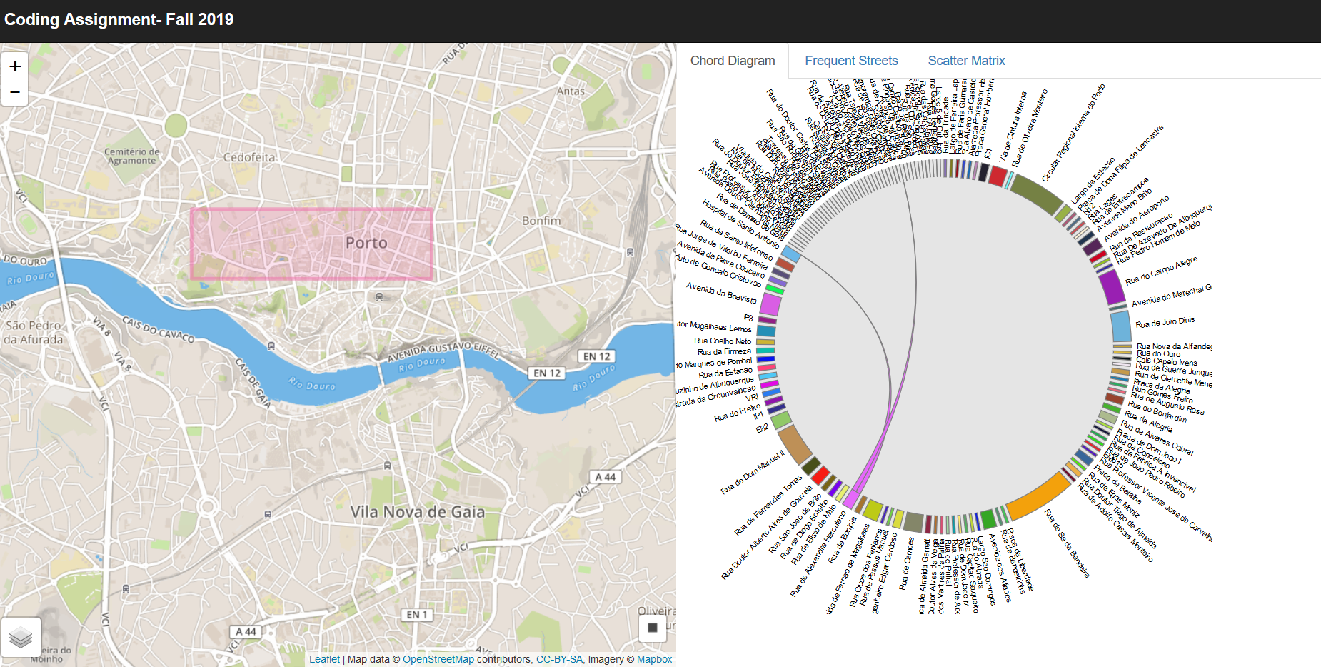

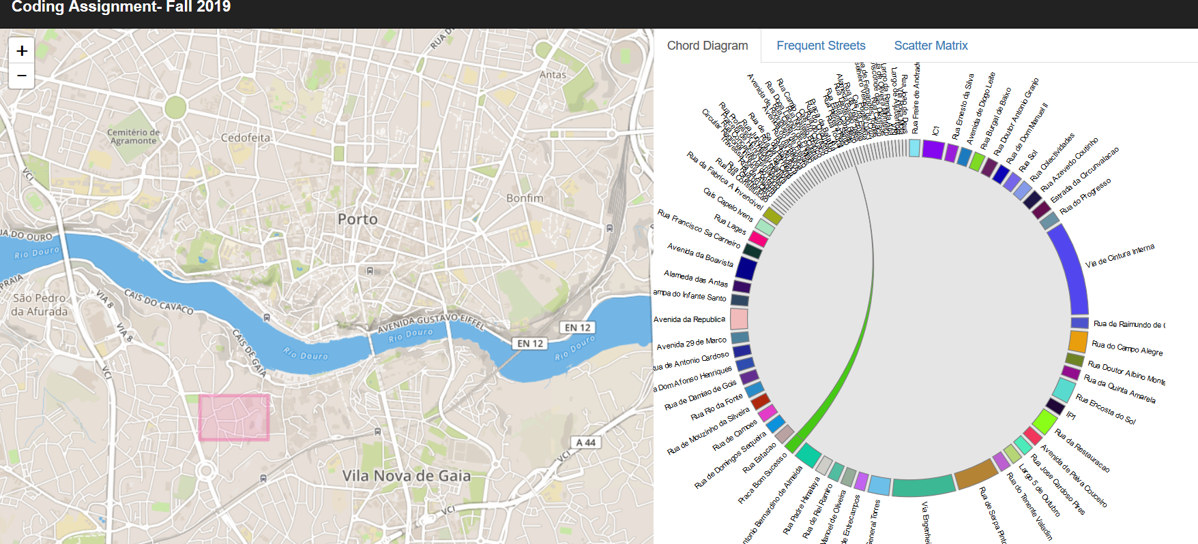

## Task 2:

Here we are showing the most frequent street names by using a word cloud.

## Word cloud:

Word Cloud is used to distinguish between the keywords in a way such that the more a specific word appears, the bigger and bolder it appears in the word cloud.

The street names from each feature in the json file is extracted and pushed in array. Counter is assigned to streetnames to know the frequencey. The size of the name in word cloud represent the frequency of the streets used.

The visualization is shown with respect to the selected area in the map as query. The visualization changes as the selected area changes.

**Conclusion:** Circular Regional Interna do Porto is the most frequent street name.

Word cloud showing most frequent streets in that area:

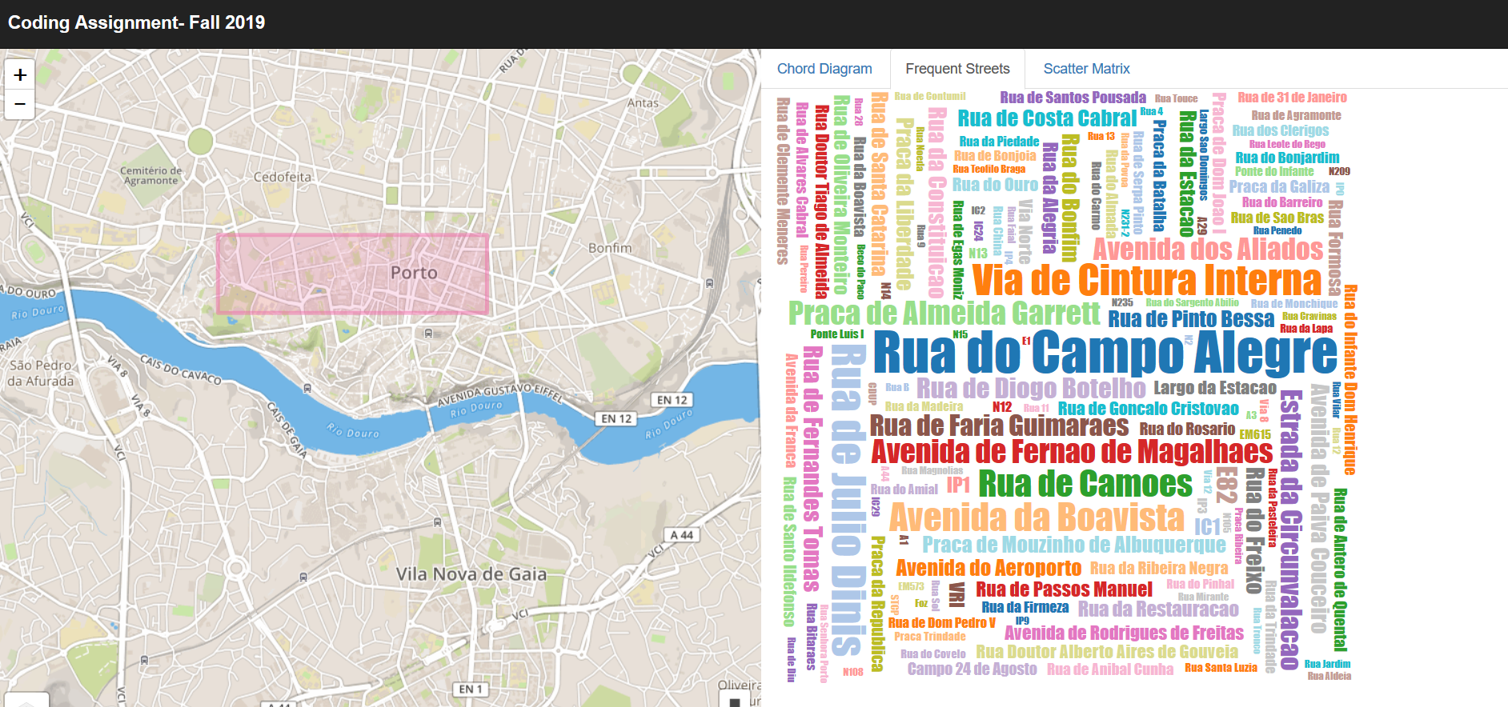

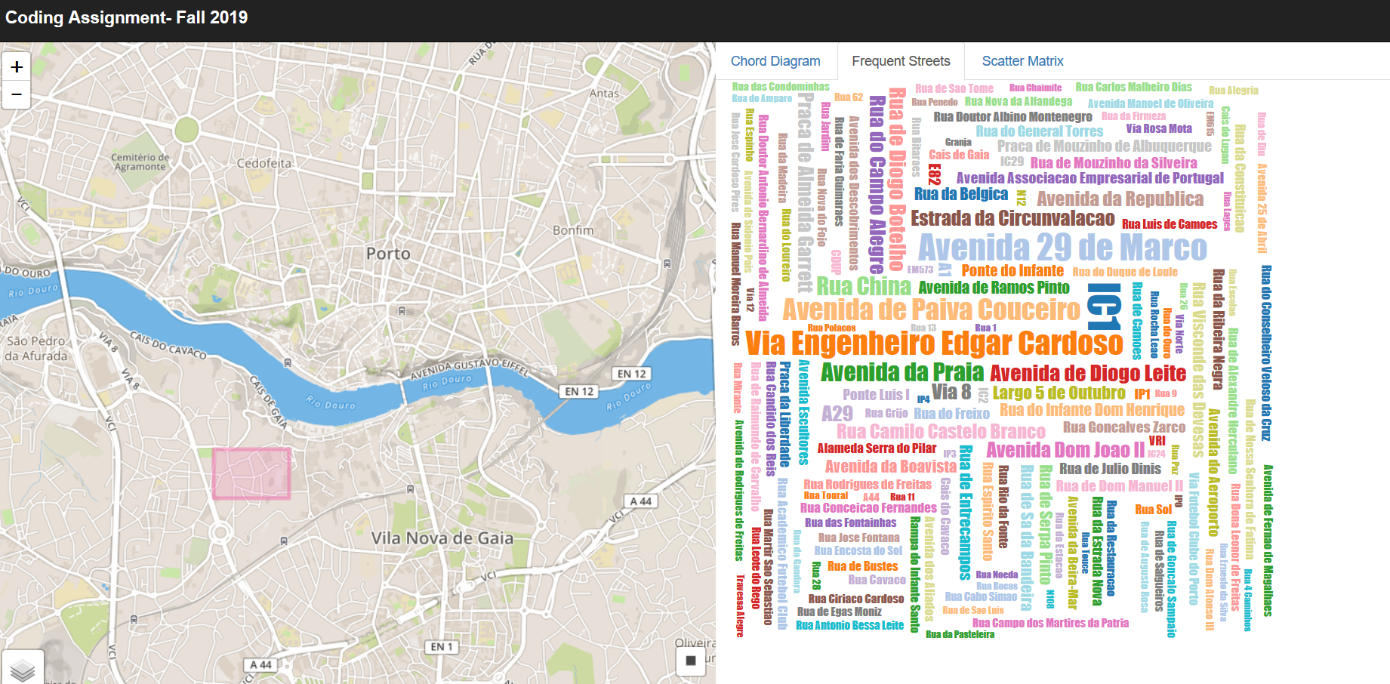

## Task 3:

Here we are showing the relationship between different attributes like average speed, distance and duration.

## Scatter-matrix:

Scatter matrix is a collection of scatter plots organized into a grid which is used to show the relationship between a pair of variables.

Required attributes can be selected to make it interactive. Data is transformed into CSV file and required fields are selected.

The visualization is shown with respect to the selected area in the map as query. The visualization changes as the selected area changes.

The below screen shots explain the working of the visualization:

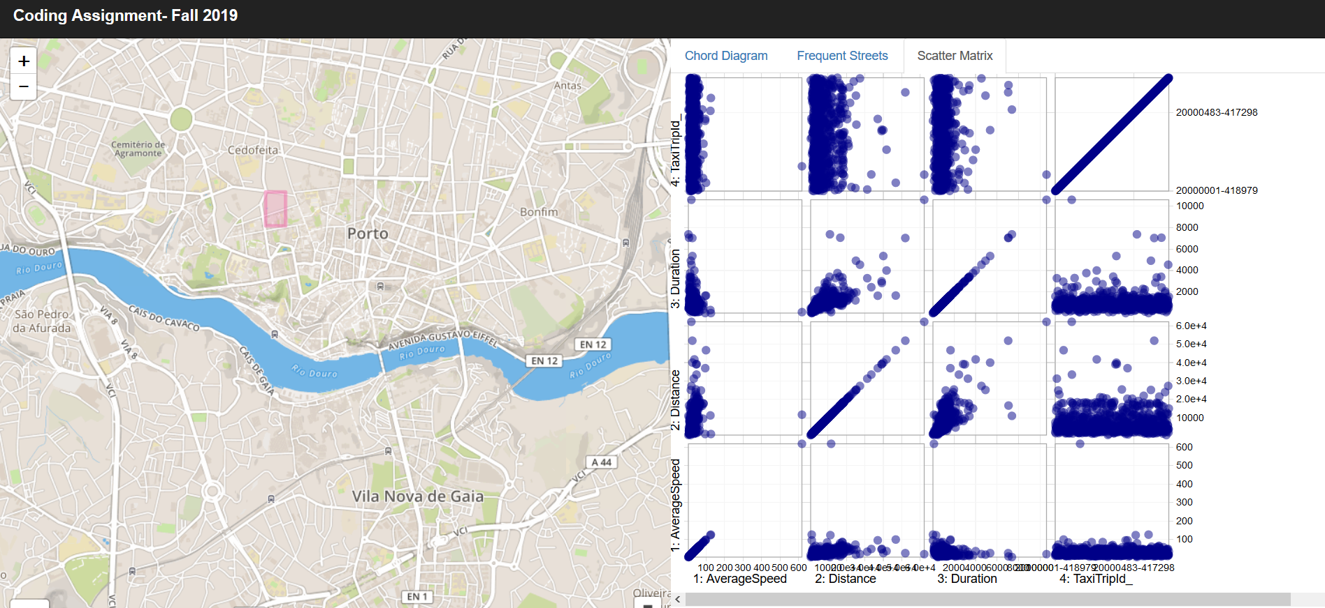

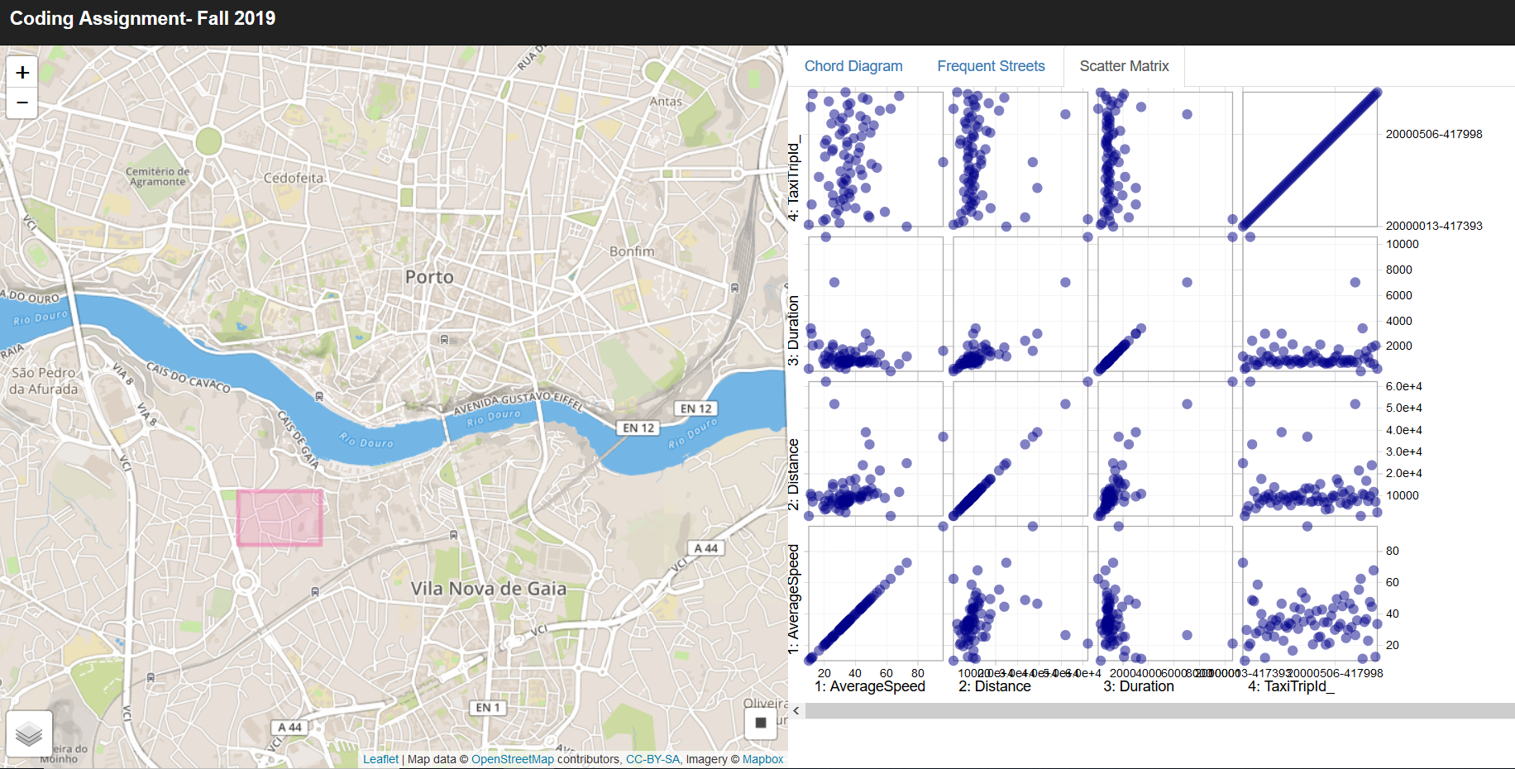

## Conclusion:

Our system in this way facilitates an easy exploration of the taxi trajectory data with interactive visual interfaces. This helps the users study taxi trajectories quickly and easily.